UK Safety Alert

Hand Injured on operating machinery

Details of the Incident

While attempting to replace a “polycord” belt, which is used to transfer products along a conveyor section, an operative suffered part amputation of his thumb. During production the operative attempted to replace a belt that had come off one of the pulley wheels. Whilst he had isolated the section of the equipment on which he was going to work he failed to isolate an adjacent section which continued to run. As a consequence his hand/glove became entangled in the moving section resulting in the part amputation of his thumb.

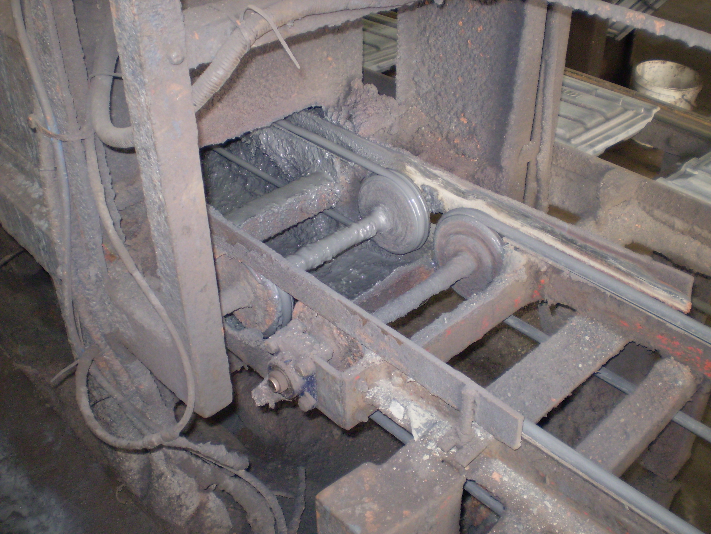

Direction of travel

Section of conveyor running and not isolated

Section of conveyor being worked on was isolated

Learning Points

The injury was caused by contact with the polycord belt system that was still operational. As part of the isolation, all associated systems should be isolated before work/maintenance commences.

- Are site isolation arrangements clear and effective?
- Are trained/authorised operatives carrying out maintenance?
- Do Safe Systems of Work detail effective isolation, including the need to isolate relevant equipment leading to / from the machinery being worked on?
- Is “Worksafe” carried out for non-routine activities?
- Are isolation arrangements clearly understood by all involved with the process?
- Are effective supervision and monitoring in place to ensure safe systems of work are followed?

